Continuous Improvement Procedure

FSC-PRO-30-011 V1-0
Draft 1

Title: | Continuous Improvement Procedure
Document code: | FSC-PRO-30-011 V1-0 EN
Approval: | Xx xxxxx xxxx
Contact: | FSC International Center  Performance and Standards Unit  Adenauerallee 134  53113 Bonn, Germany
+49-(0)228-36766-0
+49-(0)228-36766-65
psu@fsc.org
© 2021 Forest Stewardship Council, A.C. All rights reserved.
FSC® F000100

No part of this work covered by the publisher’s copyright may be reproduced or copied in any form or by any means (graphic, electronic or mechanical, including photocopying, recording, recording taping, or information retrieval systems) without the written permission of the publisher.

Printed copies are uncontrolled and for reference only. Please refer to the electronic copy on the FSC website (ic.fsc.org) to ensure you are referring to the latest version.

The Forest Stewardship Council (FSC) is an independent, not for profit, non-government organization established to promote environmentally appropriate, socially beneficial, and economically viable management of the world's forests.

FSC’s vision is where the world’s forests meet the social, ecological, and economic rights and needs of the present generation without compromising those of future generations.

Introduction
FSC seeks to improve access to, and uptake of, the FSC system by communities and owners of small forests. The FSC system consists of common Principles and Criteria (P&C) for the certification of all Management Units globally, regardless of their size, ownership, socioeconomic conditions, or types of forest systems. Despite the application of the concepts of scale, intensity and risk and small and low intensity managed forest (SLIMF) in the FSC normative framework, for smallholders and communities, particularly in tropical countries, conformity with FSC requirements is still a great challenge and involves a large investment compared to the economic benefit that FSC certification can offer.

To overcome these challenges, FSC has been developing this Continuous Improvement Procedure (CIP) that allows its users to be certified based on conformity to only a subset of forest management requirements, offering flexible steps towards conformity with the remaining requirements within a defined timeframe.

Thus, the procedure invites smallholders and communities to become part of the global FSC community of certificate holders without having perfect responsible management in place. It is enough to have initiated and implemented crucial measures and to commit to continue the path of sustainability by continuously improving forest management practices to ultimately conform with all requirements of the FSC standard within 5 years.

It is expected that the economic benefit of the FSC certification will allow the user of the CIP to cover its required investment for responsible forest management and FSC certification during the first certification cycle. Implementing this procedure will also facilitate the learning process necessary to conform with FSC requirements.

The CIP concept distinguishes between Core, Continuous Improvement and Chameleon Criteria that shall be conformed with in different points in time. The CIP user shall meet the Core Criteria and have an Action Plan to obtain FSC certification at the initial stage of the process. To maintain certification, the Continuous Improvement Criteria and Chameleon Criteria shall be met in accordance with the path established in the Action Plan during the first certification cycle of each Management Unit.
Figure 1: Continuous Improvement concept.

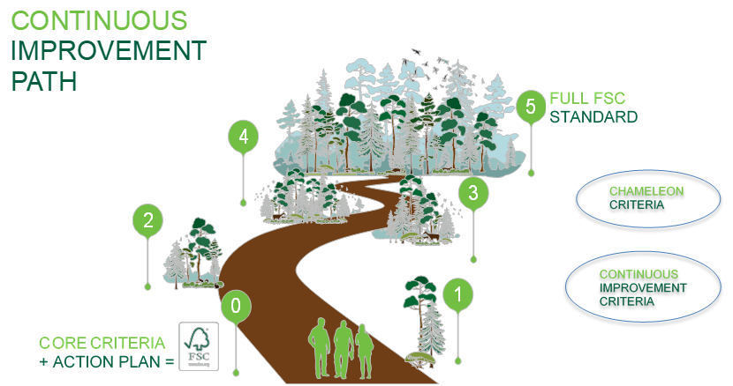

Contents
A Objective 5
B Scope 5
C Effective and validity date 5
D References 5
E Terms and definitions 5
PART I Requirements for Continuous Improvement Procedure users 9
1. Initial Self-Assessment 9
2. Development of the Action Plan 9
3. Main evaluation 11
4. Self-Monitoring 11
5. Applying the Continuous Improvement concept in forest management groups 12
PART II Requirements for certification bodies 15
6. General requirements 15
7. Audit types in the first certification cycle 15
8. Main evaluation 16
9. Years 2 and 4 evaluation 16
10. Year 3 evaluation 16
11. Re-evaluation 17
Annex 1: Self-Assessment template 18
Annex 2: Action Plan template 18

A Objective
The objective of this procedure is to provide a flexible way for The Organizations managing SLIMF Management Units and for communities, both within or outside a group, to access FSC forest management certification, by conforming to the applicable FSC standard progressively throughout a period of five (5) years.

B Scope
This procedure is for use by:
- Part I: The Organizations managing SLIMF Management Units and communities, both within and outside a group.
- Part II: FSC accredited certification bodies.
All aspects of this procedure are considered normative, including the scope, effective and validity dates, references, terms and definitions, notes, tables, and annexes, unless otherwise stated. The content of the information boxes is NOT normative.

C Effective and validity date
Approval date
Publication date
Effective date
Transition period
Period of validity Until replaced or withdrawn.

D References
The following referenced documents are relevant for the application of this document. For undated references, the latest edition of the referenced document (including any amendments) applies.
FSC-STD-01-001 FSC Principles and Criteria for Forest Stewardship
FSC-STD-01-002 FSC Glossary of Terms
FSC-STD-01-003 SLIMF Eligibility Criteria
FSC-STD-20-007 Forest Management Evaluations
FSC-STD-30-005 Forest Management Groups Standard

E Terms and definitions
For the purposes of this procedure, the terms and definitions provided in FSC-STD-01-002 FSC Glossary of Terms, and the following apply:
Action Plan: A written document that specifies the time by when the different Criteria from the applicable FSC standard will be implemented by the user of the CIP during the first certification cycle of each Management Unit.
Audit: Systematic, independent, documented process for obtaining records, statements of fact and other relevant information and assessing them objectively to determine the extent to which applicable requirements are fulfilled (adapted from ISEAL Assurance Code). Source: FSC-STD-01-002.
Audit team: Is made up of one or more auditors, one of whom is appointed to be the audit team leader. When necessary, audit teams are also supported by technical experts and/or further personnel (e.g., interpreter), who assist auditors but do not themselves act as auditors. Source: FSC-STD-01-002.

Applicable FSC standard: In the context of this procedure, this term is used to refer to the approved national standard(s) of a country or region. These can be an Interim National/Regional Standard(s) or a National/Regional Forest Stewardship Standard(s). Adapted from FSC-STD-30-005 V2-0.
Certification Body (CB): Body that performs conformity assessment services and that can be the object of accreditation (adapted from ISO/IEC 17011:2004 (E). Source: FSC-STD-01-002.
Continuous Improvement Procedure (CIP): FSC procedure that allows its users to be certified based on conformity to only a subset of the requirements of the applicable FSC standard, offering flexible steps towards full conformity with all of the remaining requirements, within the first certification cycle of each Management Unit. This is enabled by distinguishing between Core, Continuous Improvement and Chameleon Criteria that shall be conformed with in different points in time. The CIP user shall meet the Core Criteria and have an Action Plan to obtain FSC certification at the initial stage of the process. To maintain certification, the Continuous Improvement Criteria and Chameleon Criteria shall be met in accordance with the path established in the Action Plan during the first certification cycle of each Management Unit.
Core Criteria (CC): Criteria from the FSC P&C whose conformity is indispensable in the initial stage towards responsible forest management. Conformity with the CC shall be demonstrated in the main audit to obtain FSC forest management certification.
Continuous Improvement Criteria (CIC): Criteria from the FSC P&C that must be conformed with by the CIP user, according to the Action Plan, within the first certification cycle of each Management Unit.
Chameleon Criteria (CHC): Criteria from the FSC P&C whose conformity becomes mandatory before the implementation of site-disturbing activities. If no site-disturbing activities occur during the first certification cycle of the Management Unit, the CHC shall still be conformed with by the CIP user. In this case, it can be done at any time within the first certification cycle of each Management Unit.
Information Box 1. Flowchart of the initial part of the Continuous Improvement process
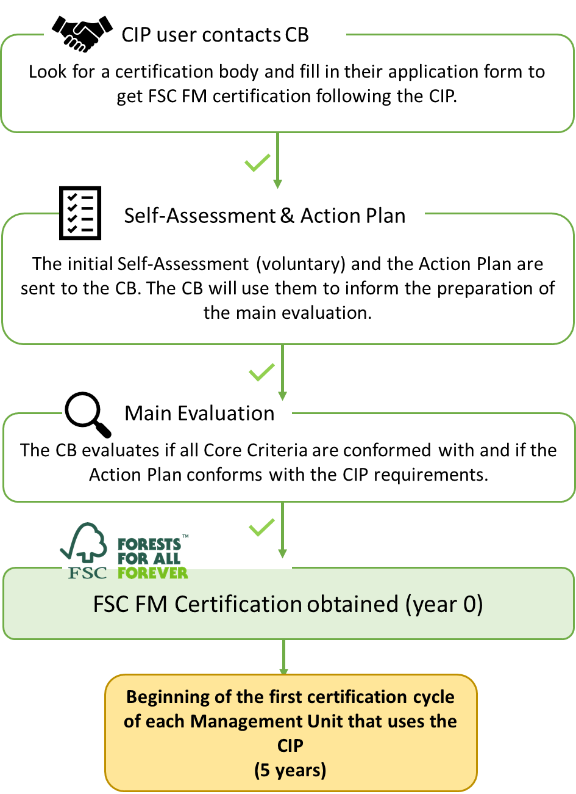

CIP user: The Organization managing SLIMF Management Units or a community (within or outside a group) willing to obtain FSC forest management certification through the implementation of the CIP.
Community: In the context of this Procedure a "community" is defined as a group of people whose Management Unit conforms to the following definition:
Community Producer: A forest Management Unit complying with the following tenure AND management criteria:
Tenure: The legal right to manage a forest Management Unit (e.g., title, long-term lease, concession) is held at the communal level, AND i) the community members must be either Indigenous Peoples or Traditional Peoples, OR ii) the forest management unit meets the SLIMF eligibility criteria.
Management: The community actively manages the forest Management Unit through a concerted effort (e.g., under a communal forest management plan) OR the community authorizes management of the forest by others (e.g., resource manager, contractors, forest products company).
If the community authorizes management of the forest by others, item i. and either item ii. or iii. of the following must be met:
i. The community’s own representative institution has legal responsibility for the harvesting operations, AND
ii. The community performs the harvesting operations OR
iii. The community’s own representative institution is responsible for the forest management decisions and follows and monitors the operations.
NOTE: The forest can be either located in a communal forest and/or on individually assigned plots, as long as the right to use the forest is communally held (e.g., this is the case for Mexican ejidos, Brazilian sustainable development reserves). Source: FSC-STD-01-002.

Evaluation: The combined processes of audit, review, and decision on a client’s conformity with the requirements of a standard (ISEAL Assurance Code). Source: FSC-STD-01-002.
Types of evaluation:
Pre-Evaluation: Assessment to determine the applicant’s readiness for their main evaluation.
Main Evaluation: Assessment of an applicant for FSC certification.
Re-Evaluation: Assessment for re-certification.
Surveillance Evaluation: Systematic repetition of conformity assessment activities as a basis for maintaining the validity of FSC certification.
Indigenous Peoples: People and groups of people that can be identified or characterized as:
- The key characteristic or criterion is self-identification as Indigenous Peoples at the individual level and acceptance by the community as their member.
- Historical continuity with pre-colonial and/or pre-settler societies.
- Strong link to territories and surrounding natural resources.
- Distinct social, economic, or political systems.
- Distinct language, culture, and beliefs.
- Form non-dominant groups of society.
- Resolve to maintain and reproduce their ancestral environments and systems as distinctive peoples and communities.
(Source: Adapted from United Nations Permanent Forum on Indigenous Issues, Factsheet ‘Who are Indigenous Peoples’ October 2007; United Nations Development Group, ‘Guidelines on Indigenous Peoples’ Issues’ United
Nations 2009, United Nations Declaration on the Rights of Indigenous Peoples, 13 September 2007) Source: FSC-STD-01-001 V5-2.
Site-disturbing activities: Forest management activities with a risk of adversely impacting any value of the forest, including economic, environmental and/or social values. Source: FSC-STD-30-005 V2-0.
SLIMF (Small or low intensity managed forest): A forest Management Unit which meets specific FSC requirements related to size and/or intensity. Source: FSC-STD-20-012 V1-1.
Technical expert: A person supporting an audit team by providing specific knowledge or expertise about a specific sector, content, process, or activity being audited. The person does not act as auditor. Source: FSC-STD-20-001 V4-0.
Traditional Peoples: Traditional Peoples are social groups or peoples who do not self-identify as Indigenous and who affirm rights to their lands, forests and other resources based on long established custom or traditional occupation and use (Source: Forest Peoples Program (Marcus Colchester, 7 October 2009).Source: FSC-STD 01-001 V5-2
Verbal forms for the expression of provisions (Adapted from ISO/IEC Directives Part 2: Rules for the structure and drafting of International Standards)
“shall”: indicates requirements strictly to be followed in order to conform with the standard.
“should”: indicates that among several possibilities one is recommended as particularly suitable, without mentioning or excluding others, or that certain course of action is preferred but not necessarily required. A Certification Body (CB) can meet these requirements in an equivalent way provided this can be demonstrated and justified.
“may”: indicates a course of action permissible within the limits of the document.
“can”: is used for statements of possibility and capability, whether material, physical or causal.
NOTE: Part I describes the requirements for The Organization that qualify as CIP user to obtain FSC forest management certification. This part is only applicable in the first 5-year certification cycle of each Management Unit. In the case of group certifications, the CIP is applicable during all certification cycles, but within the group, it can only be used by each Management Unit during the first 5 years of the group membership. After the first 5 years, Management Units that have been applying the CIP must have conformed with the full applicable FSC standard.
Part II contains the additional requirements to FSC-STD-20-007 Forest Management Evaluations that certification bodies must conform with when evaluating organizations that are applying this procedure. Subsequently, these requirements will be incorporated into FSC-STD 20-007 Forest Management Evaluations.
Any part of the process to obtain FSC forest management certification that is not explicitly mentioned in this procedure will follow the regular process for FSC forest management certification.

PART I Requirements for Continuous Improvement Procedure users

Initial Self-Assessment
  - The CIP user should carry out a self-assessment to analyze their initial situation (baseline) and level of conformity to the Criteria of the applicable FSC standard.
NOTE: Although voluntary, it is strongly recommended to implement an initial self-assessment, since it can serve as training, provide educational value, empowerment, and ownership of the process by the CIP user.
  - The initial self-assessment can be carried out by following the template provided in Annex 1, or the CIP user can also use any other template or tool.
  - If the CIP user carries out an initial self-assessment, the results shall be sent to the CB at least thirty (30) days prior to the main evaluation.

Development of the Action Plan
  - The CIP user shall develop an Action Plan by taking into consideration the Criteria classification as prescribed in Table 1.
Table 1: Categorization of Criteria of the FSC P & C V5 (FSC-STD-01-001 V5-2)
Principle | Core Criteria  (CC) | Chameleon Criteria  (CHC) | Continuous Improvement Criteria  (CIC)
1 | 2, 3, 5, 6, 7, 8 |  | 1, 4
2 | 1, 4, 6 | 3, 5 | 2
3 | 1, 2, 3, 4 |  | 5, 6
4 | 1, 2, 6 |  | 3, 4, 5, 7, 8
5 |  | 2 | 1, 3, 4, 5
6 | 1, 4, 7, 9, 10 | 2, 3, 5 | 6, 8
7 | 1 | 2 | 3, 4, 5, 6
8 | 5 |  | 1, 2, 3, 4
9 |  | 1 | 2, 3, 4
10 | 2, 3, 4, 5, 7, 8 | 1, 10, 11 | 6, 9, 12
TOTAL | 29 | 11 | 30

  - For those countries where the applicable FSC standard is still based on the P&C Version 4, the CIP user shall develop an Action Plan by taking into consideration the Criteria classification as prescribed in Table 2.

Table 2: Categorization of all the Criteria of the FSC P& C V4 (FSC-STD-01-001 V4-0)

Principle | Core Criteria  (CC) | Chameleon Criteria  (CHC) | Continuous Improvement Criteria  (CIC)
1 | 1,2,3,4,6 |  | 5
2 | 1,2,3
3 | 1,2 |  | 3,4
4 | 3,5 | 2 | 1,4
5 |  | 3,6 | 1,2,4,5
6 | 2,6,8,9,10 | 1,4,5 | 3,7
7 |  | 1, 3 | 2,4
8 | 3 |  | 1,2,4,5
9 |  | 1 | 2,3,4
10 | 1,2,4,7,8,9 | 5,6 | 3
TOTAL | 24 | 11 | 21
  - The CIP user shall develop the Action Plan by following the template provided in Annex 2.
  - If the CIP user has developed an initial self-assessment, its results shall be used as input for the development of the Action Plan.
  - In the Action Plan, the CIP user shall define which Criteria of the applicable FSC standard shall be implemented in which year, by applying the following rules:
    - Conformity with the CC shall be demonstrated in the main evaluation.
    - The CIP user shall decide the year in which they plan to implement each of the CIC, by applying the following rules:
- 50% of the CIC shall be implemented from year one (1) to year three (3); the remaining 50% of CIC shall be implemented from year four (4) to year five (5).
- All CIC shall be implemented before the re-evaluation of each Management Unit.
  - If the CIP user, for any reason, is unable to implement all planned CIC for a given year, up to two (2) of the CIC can be carried over to the following year. The change is subject to approval by the CB and must be communicated with a justification to the CB at least thirty (30) days prior to the next surveillance evaluation. If the CB does not approve the change, the Criteria shall be implemented as planned in the Action Plan.
  - The CIP user shall decide the year in which they plan to implement each of the CHC, by applying the following rules:
- The CIP user shall define what constitutes site-disturbing activities within their Management Unit with a justification. Identified site-disturbing activities are subject to the approval by the CB during the main evaluation.
- The CIP user shall define in which year they plan to conduct the site-disturbing activities. The site-disturbing activities, the corresponding CHC, and when the CHC will be implemented shall be included in the approved Action Plan.
- Each CHC shall be implemented before conducting any site-disturbing activity.
  - If any changes are required in the planning and execution of the site-disturbing activities and their corresponding CHC , the CIP user shall update the Action Plan and communicate the changes to the CB, at least thirty (30) days prior to the next surveillance evaluation.
  - When no site disturbing activities are undertaken during the first certification cycle of each Management Unit, the CIP user can choose freely in which year each of the CHC will be implemented and shall introduce this planning in the Action Plan.
  - All CHC shall be implemented before the re-evaluation of each Management Unit.
NOTE: During the Action Plan development, the CIP user may consider that some Criteria are not applicable to its Management Unit. For example, when there are no Indigenous Peoples in the region, Criteria of Principle 3 are probably not applicable. The CIP user can suggest the non-applicability of Criteria to the CB. The final decision about the applicability of Criteria rests with the CB.
  - The CIP user shall share the Action Plan with the CB at least thirty (30) days before the main evaluation.

Information Box 2. Examples of site-disturbing activities
The implementation of CHC is mandatory before site-disturbing activities are conducted. The CIP user will have to define and provide a justification of what constitutes a site-disturbing activity for their Management Unit. Examples of site-disturbing activities are the following:
Timber, energy wood and some non-timber forest products harvesting, including commercial logging/extraction methods.
In case of non-timber forest products harvesting might imply a negative impact to the forest depending on the type of product, or only on specific years when the product is harvested;
Soil preparation;
Planting or seeding;
Stand management; fertilization; thinning; pruning; fuel management; chemical pesticides use;
Post-harvest remediation activities.
Infrastructure development (e.g., forestry road construction or road decommission (closure);
.

Main evaluation
  - The CIP user shall pass a main evaluation by a CB to achieve FSC forest management certification.
NOTE: During the main evaluation, the CB checks conformity with the CC, the adequacy of the Action Plan developed by the CIP user and the activities that the group entity has classified as site-disturbing for their Management Units.
NOTE: Once certified, the CIP user has full access to the labels, trademarks, and marketing options as any other Organization that has achieved FSC forest management certification.

Self-Monitoring
  - The CIP user shall implement self-monitoring in years two (2) and four (4) by responding to the following questions:
- Did any site-disturbing activities take place since the last CB evaluation?
- Is the Action Plan being implemented in a timely manner?
- Are there any unresolved stakeholder complaints?
  - The CIP user shall send the results of the self-monitoring, together with supporting evidence, to the CB, at least sixty (60) days prior to the next surveillance evaluation to inform their decision on the type of audit, if any, for that year.

Information Box 3. Differences between initial Self-Assessment and Self-Monitoring
The following table specifies the differences between initial Self-Assessment and Self-Monitoring:
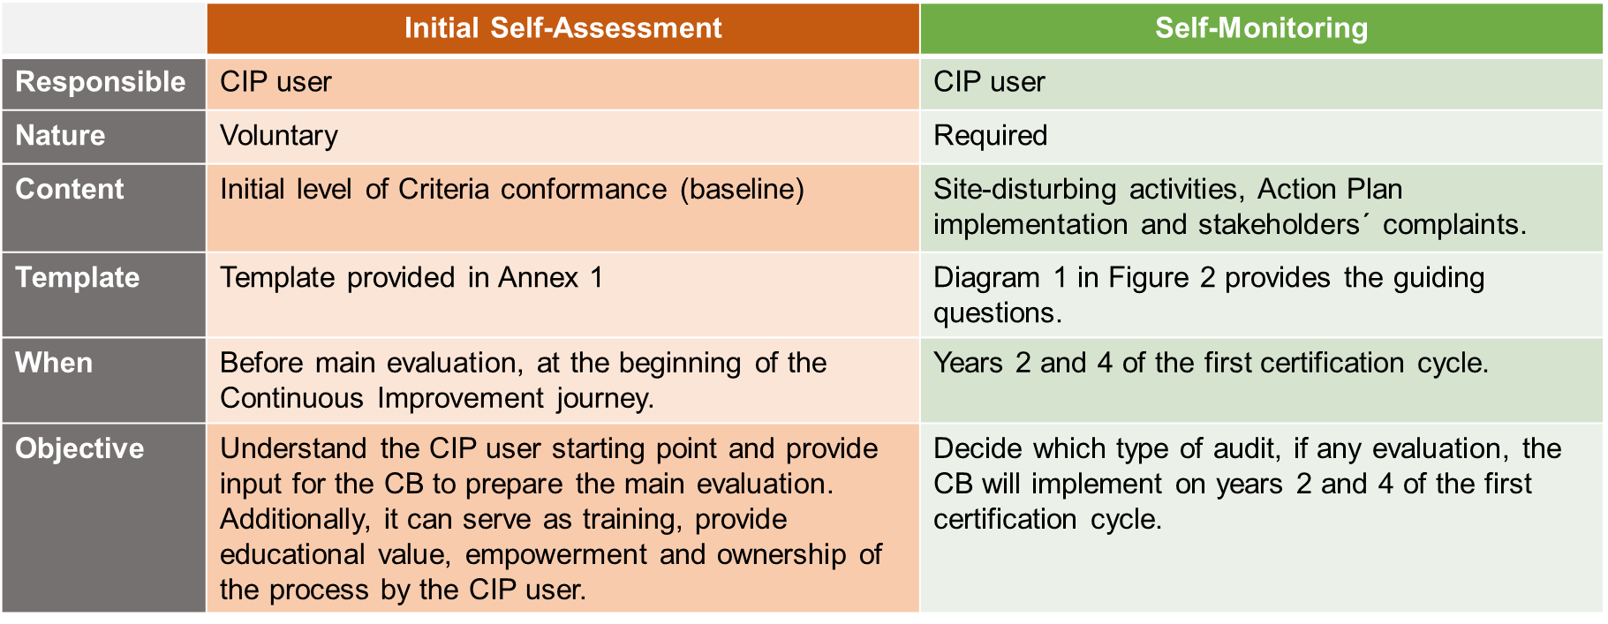

Applying the Continuous Improvement concept in forest management groups
  - The group entity shall develop one Action Plan for the whole group according to Section 2 of this procedure.
  - The group entity shall establish which activities are classified as site-disturbing in the Management Units of the group.
  - The group entity shall implement an initial internal evaluation of its CIP users to verify the conformity of their Management Units with all CC and their commitment to implement the Action Plan.
  - The group entity shall pass a main evaluation by a CB to achieve FSC group forest management certification.
NOTE: During the main evaluation, the CB checks conformity with the CC in the Management Units of the group, the adequacy of the Action Plan developed by the group entity, and the activities that the group entity has classified as site-disturbing.
  - The group entity shall define how the CIP shall be operated in its group, using the following options:
    - New Management Units can only be added to the group every 5 years when a new certification cycle begins, and all new members will start at the year zero (0) of the Action Plan implementation. OR
    - New Management Units can join the group at any year of the certification cycle. In this case one or both of the following options can be implemented:
    - The group entity shall form a subgroup and all its member start in year zero (0) of the Action Plan implementation.
    - New Management Units can join a group or sub-group at a year different than year zero (0) of the Action Plan implementation. In this case the group entity shall verify that the applicant conforms with all requirements corresponding to the year of Action Plan Implementation in which the applicant will join the group or sub-group.
  - The group entity shall have sufficient capacity and resources to manage the options for the application of this procedure that it chooses for its group.
NOTE: It is strongly recommended that a group does not form more than one subgroup during a certification cycle, as this may increase the cost and complexity of the audits.

Information Box 4. Different ways in which a group can operate the CIP
Option 1. A new group use CIP and allows new members to join every 5 years
A new group becomes certified using the CIP and members start in year “0” of the Action Plan cycle.
After completing the 5-year certification cycle, new members join the group and form a subgroup using the CIP and start again in year "0" of the Action Plan cycle.

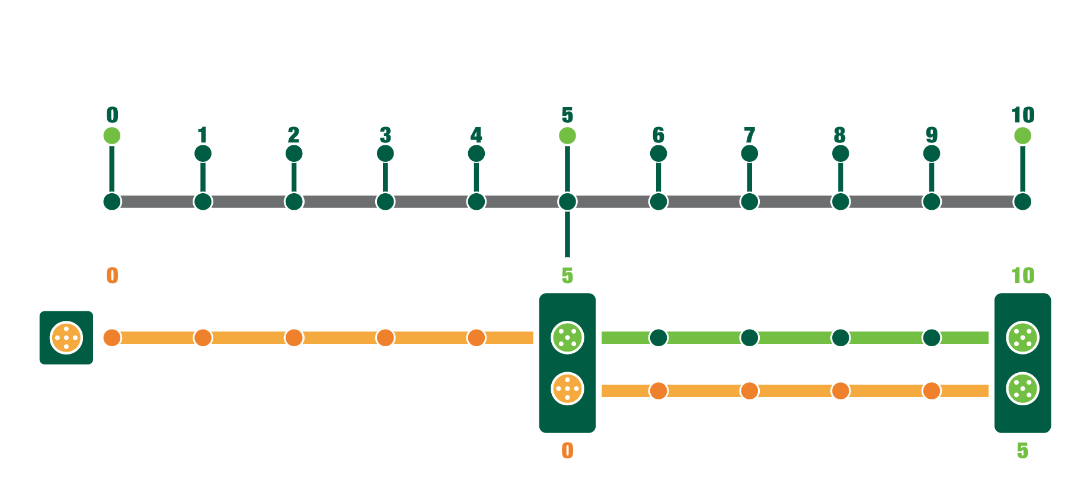
Option 2: A FSC certified group permit new member to join and form a subgroup
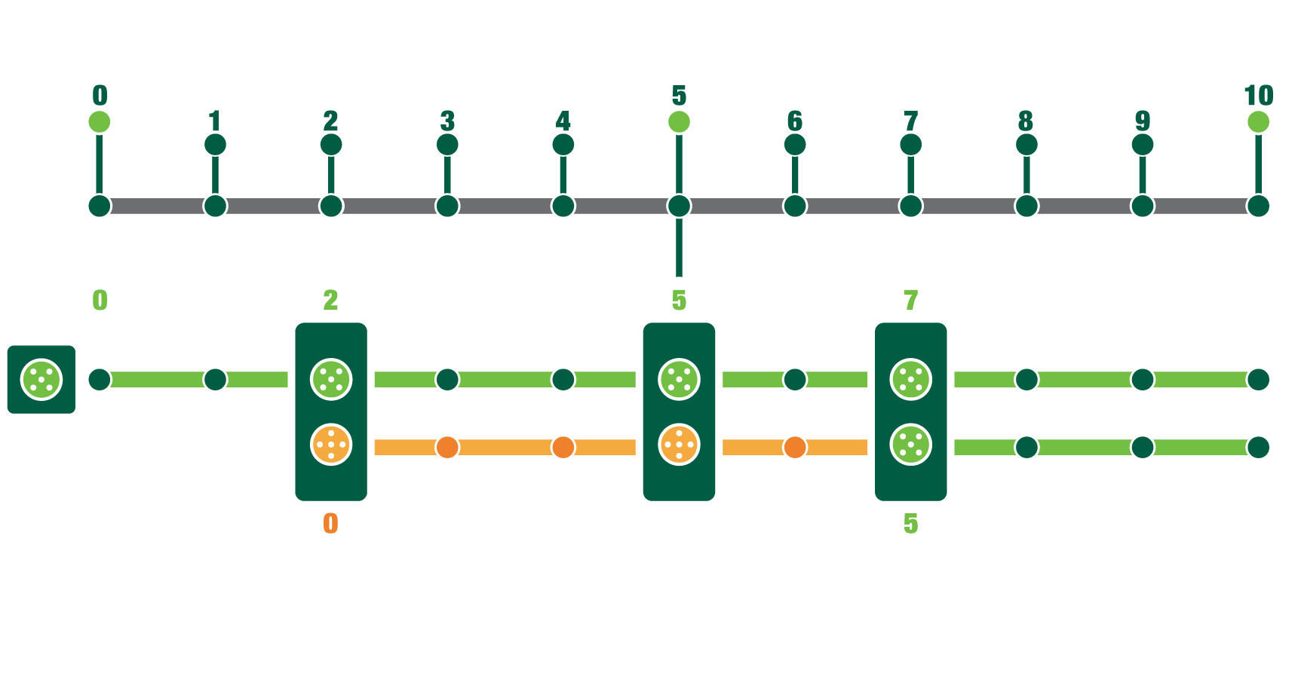
New members enter the FSC certified group in year 2 of their certification cycle. They form a subgroup using the CIP and start in year “0” of the Action Plan cycle.

Take a note: During the group´s main audit in year 5 the subgroup will still have an annual surveillance. From year 7 of the certification cycle all members continue using “normal” FSC procedure.

Option 3. New members join the subgroup of the FSC certified group
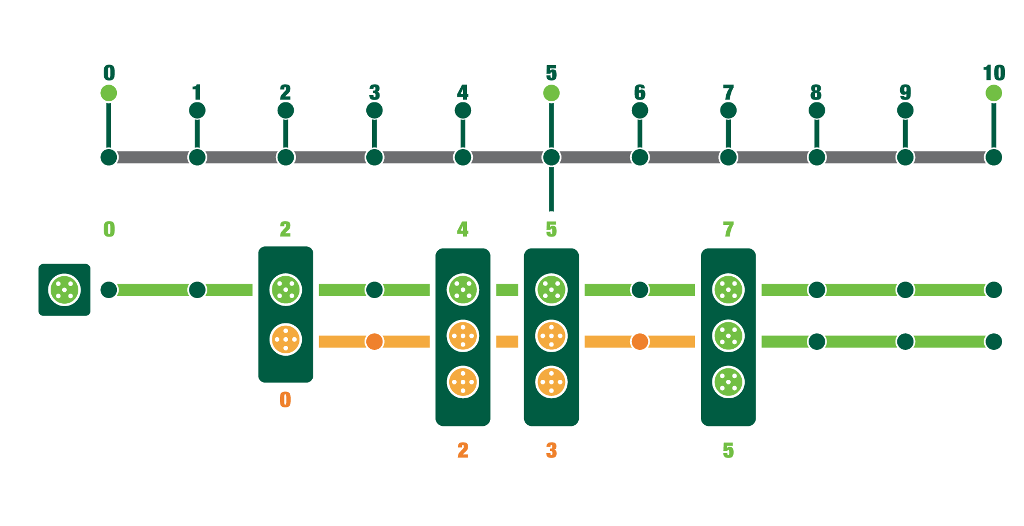
New members enter the FSC certified group in year 2 of their certification cycle. They form a subgroup using the CIP and start in year “0” of the Action Plan cycle.

In addition, other new members enter the subgroup in year 2 and 3 of the Action Plan cycle. Before they can join the subgroup, applicants shall conform with all corresponding requirements of the Action Plan for year 2 and 3, respectively.

Option 4. A new group use CIP and every year new members join the group
A new Group becomes certified using the CIP. The members start in year “0” of the Action Plan cycle.

In addition, other new members enter the group in year 1,2,3, and 4 of the Action Plan cycle. Before, they can join the group, the applicants shall conform with all requirements corresponding to year 1, 2, 3 and 4 of the Action Plan, respectively.

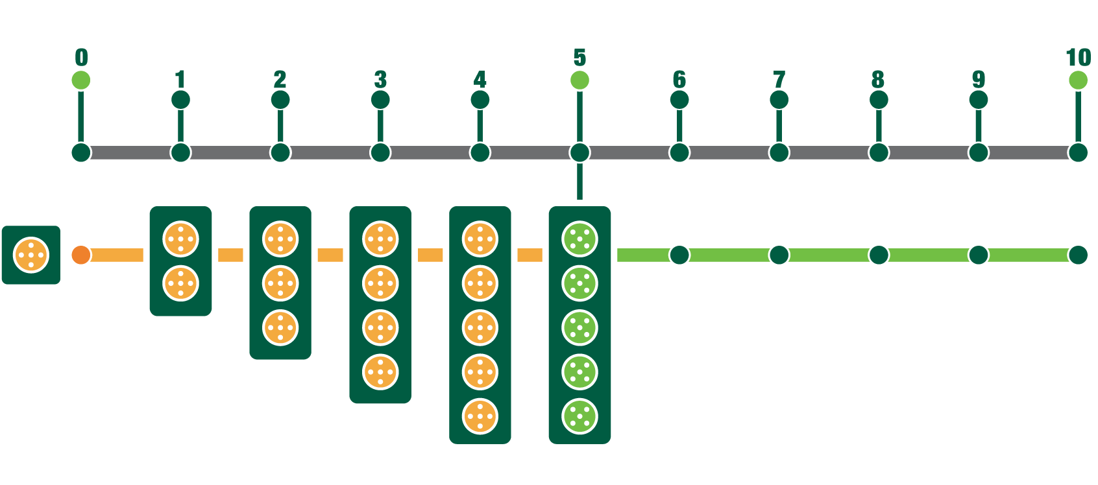
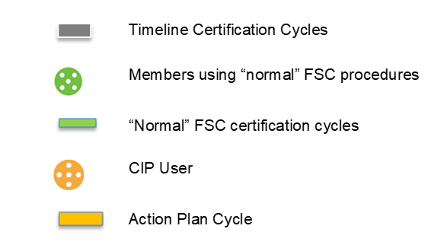

PART II Requirements for certification bodies

General requirements
In addition to the requirements in FSC-STD-20-001 General requirements for FSC accredited certification bodies, the CB shall conform with the following general requirements:
  - At least one (1) audit team member shall have knowledge on cultural aspects of smallholders and communities and social auditing techniques with a strong focus on culturally appropriate interactions.
  - A technical expert shall be used.
  - If instructed by the audit team leader, the technical expert is allowed to perform interviews and other specified tasks unaccompanied.
  - When the CIP user has been supported by a third person (consultant, local expert, NGO, etc.) for the conformity with a requirement from the applicable FSC standard and if the CIP user agrees, the CB shall address this third person during the evaluation of such requirement.
  - The CB shall evaluate the action taken by the CIP user to close non-conformities as much as possible remotely by applying Information and Communication Technology (ICT).

Audit types in the first certification cycle
  - The CB shall follow the concept depicted in Figure 2 and Diagram 1 below to determine the type of audit, if any, to be implemented in each year.

Figure 2: Type of audits during the first certification cycle, including content for the Self-Monitoring by the CIP user (Diagram 1) on years 2 and 4.

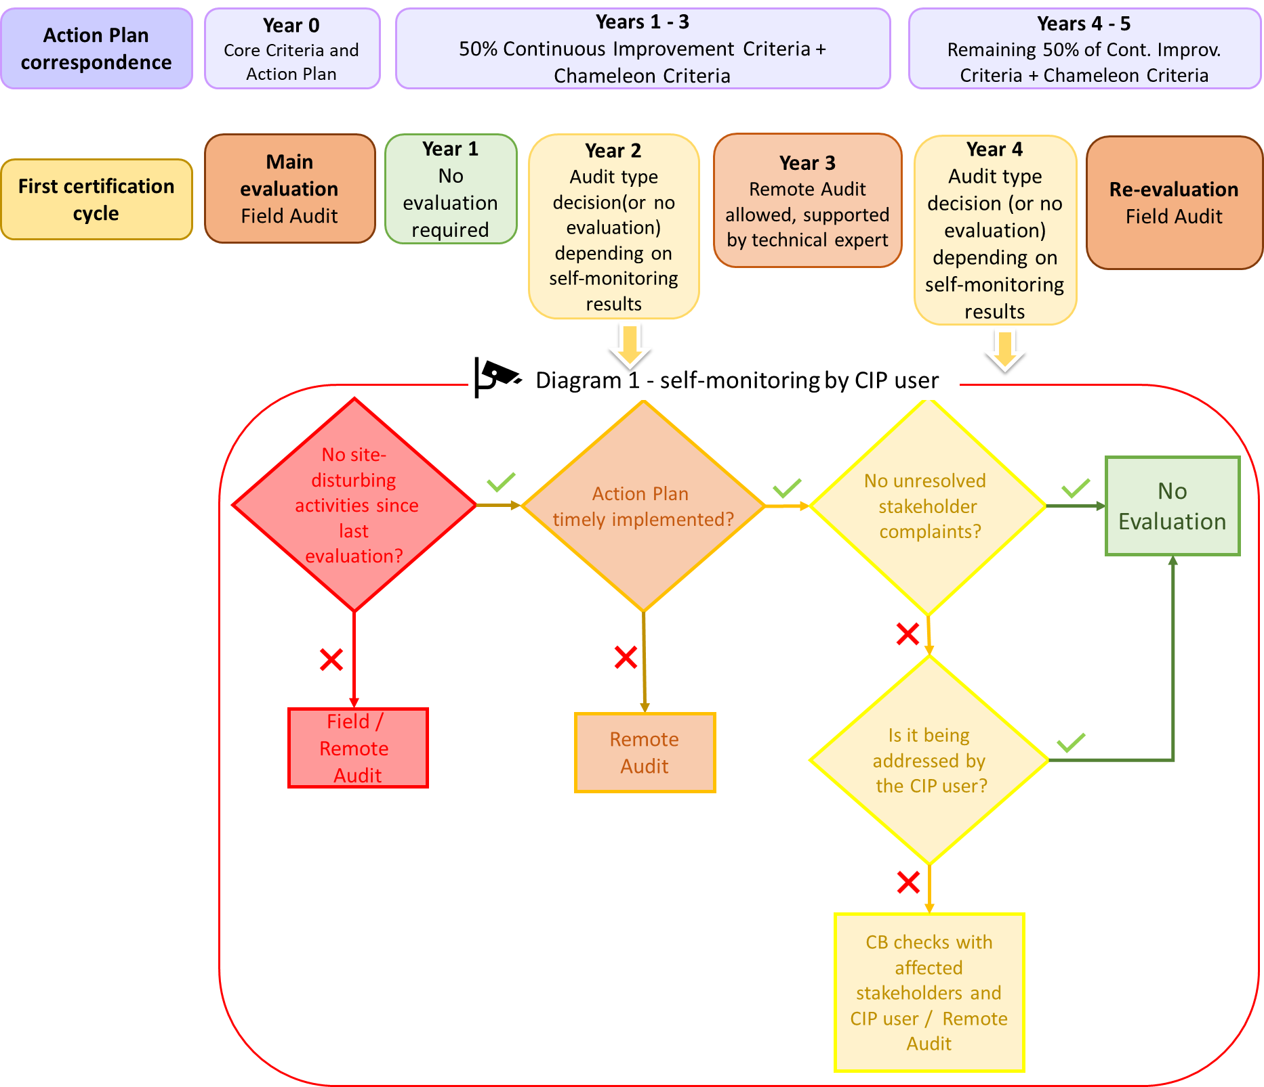

Main evaluation
  - If the CIP user has conducted an initial self-assessment, the CB shall use the results as input to prepare for the main evaluation.
  - During the main evaluation, the CB shall evaluate whether the CIP user:
- Conforms with all the CC of the applicable FSC standard;
- Has developed an Action Plan that conforms with the requirements of Section 2 of this procedure.
- Has defined what constitutes site-disturbing activities within the Management Unit and provided the required justification.

Years 2 and 4 evaluation
  - In years 2 and 4, the CB shall use the results of self-monitoring and evidence provided by the CIP user to decide whether an evaluation is required or not. If an evaluation is required, the CB shall decide which of the following types of audit will be implemented:
- Field audit: The CB shall implement a field audit.
- Remote audit: The CB shall implement a remote or desk audit focusing on the applicable Criteria to be conformed with in that year. In the remote audit:
      - The documentation requests shall be reduced to a minimum.
      - Information and Communication Technology (ICT), including the FSC GIS Portal, shall be used as much as possible.
      - The remote audit shall be performance oriented, focusing on the management activities implemented by the CIP user.
      - Administrative requirements shall be checked in the next field audit.
  - When there is an unresolved complaint by a stakeholder, the CB shall contact the CIP user and the affected stakeholders to follow up the status of the complaint and the process to solve it. If deemed necessary, this contact should be followed by a remote audit.
  - When the CB decides to implement an evaluation in year 2 or 4, the CB shall verify that the CIP user:
- Continues to conform with the CC;
- Conforms with the CIC allocated up to that year in the Action Plan;
- Conforms with any CHC that have been activated up to that year in the Action Plan.

Year 3 evaluation
  - In year three (3), the CB shall implement a remote audit supported on the ground by a technical expert to verify that the CIP user:
- Continues to conform with the CC;
- Conforms with the CIC allocated to the first three (3) years of the Action Plan;
- Conforms with any CHC that have been activated in the first three (3) years of the Action Plan.
  - The CB shall analyze the results of the remote audit and the input from the technical expert and decide whether a field audit is necessary to check that the CIP user conforms with item a, b, and c from Clause 10.1.

Re-evaluation
  - For the re-evaluation in year five (5), the CB shall implement a field audit to verify that the CIP user conforms with all Criteria of the applicable FSC standard.

Annex 1: Self-Assessment template
The Self -Assessment template can be found in an attached excel file. (in development)

Annex 2: Action Plan template
The Action Plan template can be found in an attached excel file.

See FSC-PRO-60-007 Structure, Content and Development of Interim National Standards for the definition of “Interim National Standard”, “Interim Regional Standard” and “National Forest Stewardship Standard”.

